* Give all items an ID, for sub components use A, B, C for both the BoM you are working on and the reference BoM (both must already be opened workbooks)
  + 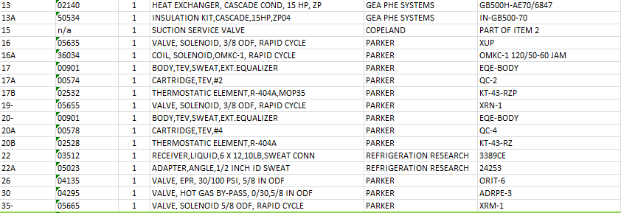
  + Exceptions to this are items at the end
    - 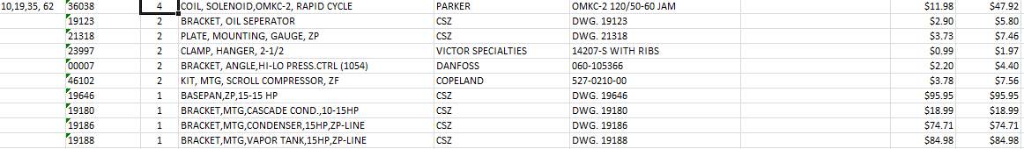
* Drag the program into the VBA Project
  + 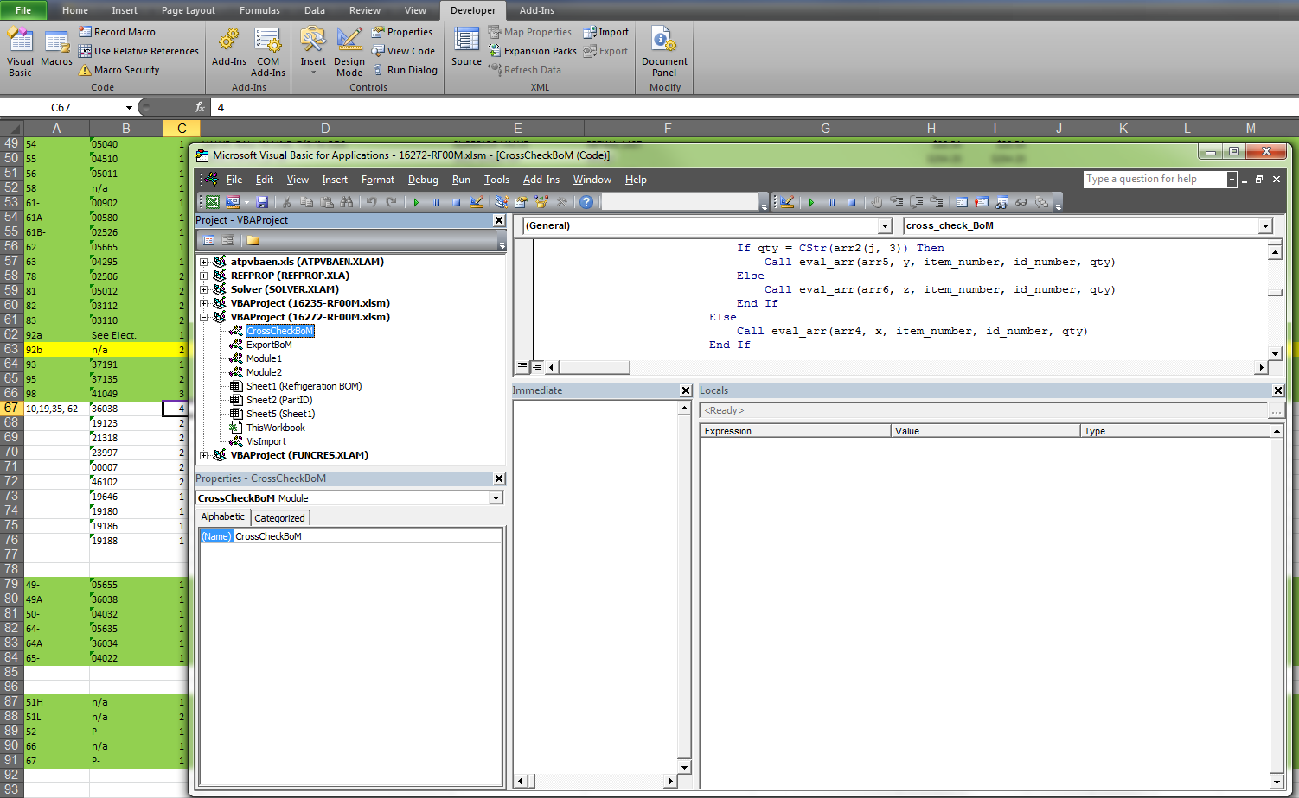
* Highlight the items you wish to compare on both BoMs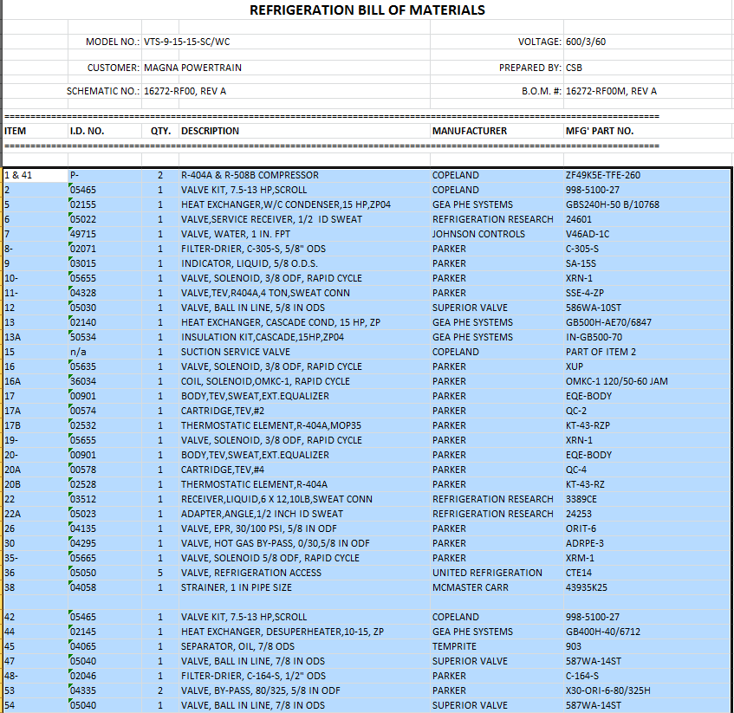
* Run the Program
  + 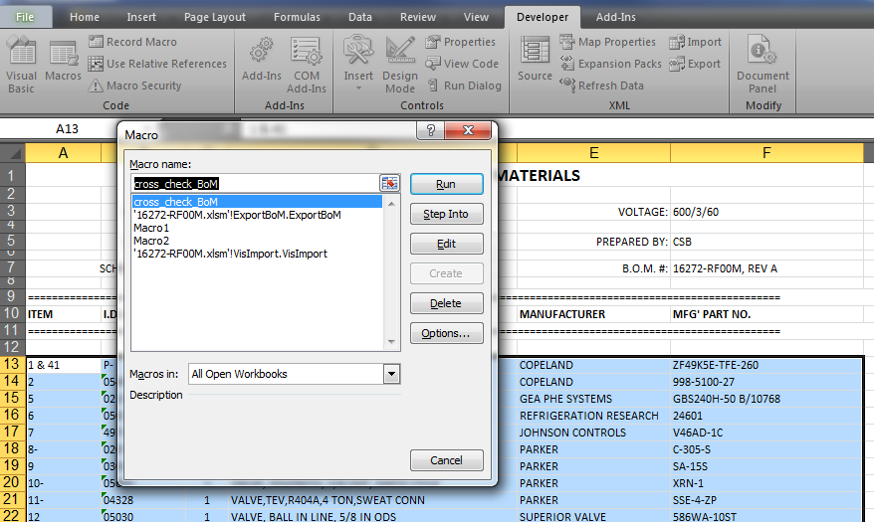
* Type in the name of the BoM you wish to compare (it must appear exactly as the file name and is case sensitive)
  + 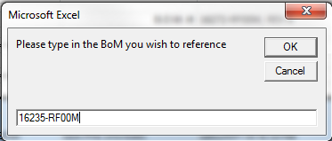
* A new sheet will be added to the BoM that gives a breakdown of:
  + Items that are on the BoM you are working on but not on the reference drawing
  + Item ID does not match the reference drawing
  + Quantity of item varies from the reference drawing
  + Items that are not on the new BoM
  + Items that match